On
www.dell.com
available some usefull software.

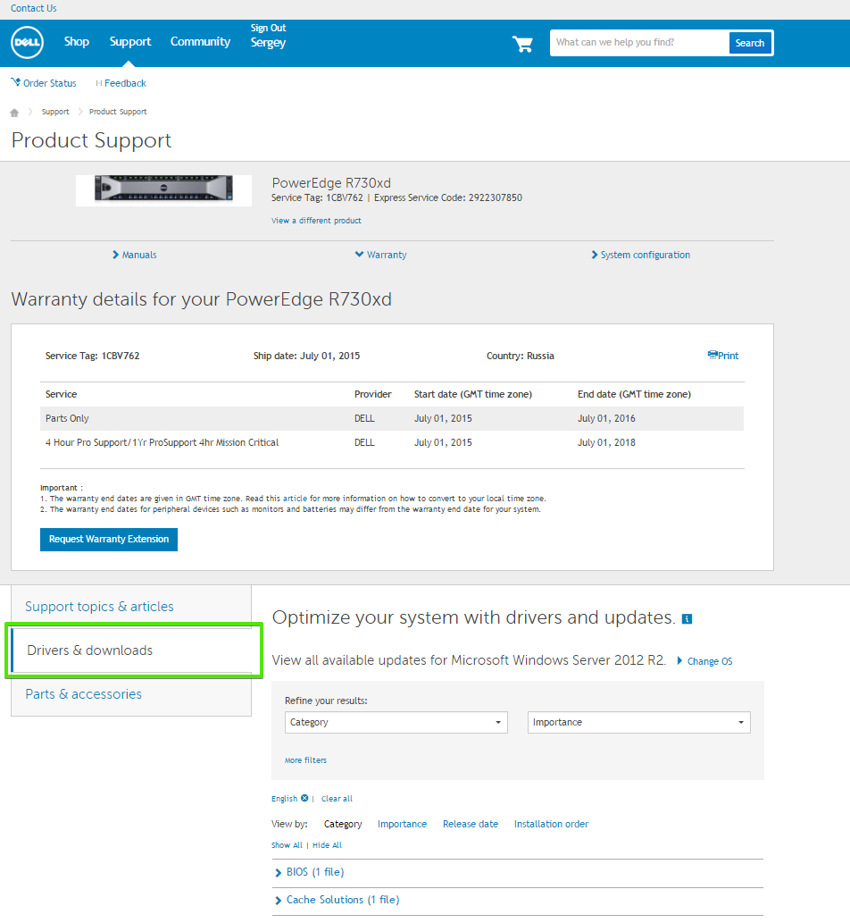

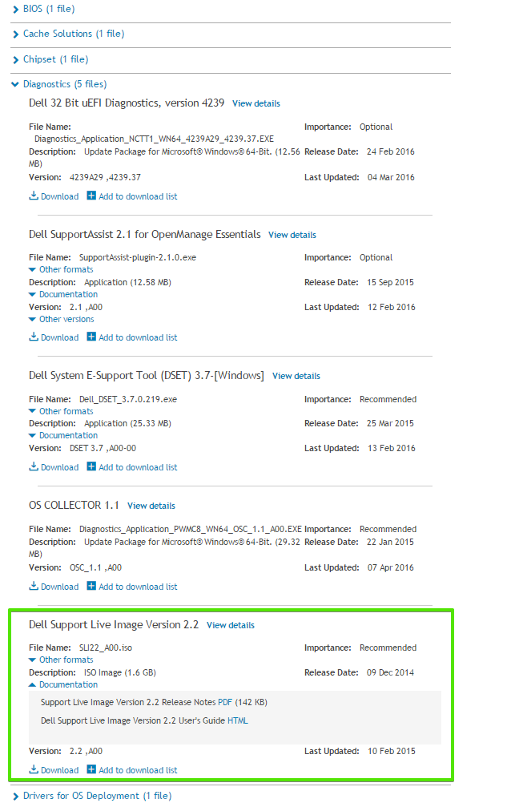

Dell Support Live Image Version 2.2

Support Live Image is a CentOS 7.0 image that packages a collection of utilities and diagnostic tools for Dell PowerEdge Servers, Dell PowerEdge C Servers, and Dell PowerVault Storage Systems. It provides an environment for the tools to run to troubleshoot hardware-related issues and gather system configuration information. The results of the diagnostic tests and configuration information are sent to the technical support team to identify and resolve an issue.

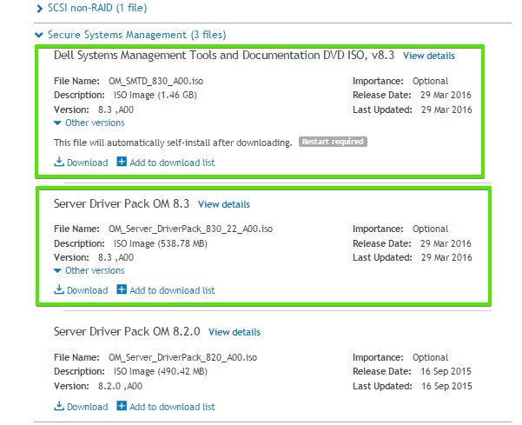

Dell Systems Management Tools and Documentation DVD ISO, v8.3

The Dell Systems Management Tools and Documentation DVD provides a consolidated toolset for managing Dell systems through the entire system lifecycle: deployment, monitoring and update. This DVD includes: Dell Systems Build and Update Utility, the OpenManage Server Administrator agent, Systems Service and Diagnostics Tools and Systems Documentation. The Full ISO is located below. If you download the Full ISO - It is recommended to utilize the Dell Download Manager

Server Driver Pack OM 8.3

PE Drivers for deployment for both bare-metal and Operating systems specifi

